Abstract: As artificial intelligence becomes increasingly integrated into biometric systems, ensuring transparency and explainability in decision-making processes is crucial. This project focuses on developing an explainable AI model for a keystroke dynamics biometric system. Keystroke dynamics analyze an individual's typing patterns, offering a non-intrusive and resource-efficient biometric modality suitable for environments without GPU capabilities.

1. Introduction

In an increasingly digital world, the demand for secure authentication methods has never been greater. Keystroke dynamics recognition, a behavioral biometric technique, has emerged as a promising solution, leveraging the unique typing patterns of users for identity verification. Unlike traditional password-based systems, keystroke dynamics add a layer of behavioral security, enhancing resilience against common threats such as password theft and brute-force attacks.

Despite its advantages, the adoption of keystroke recognition systems is often hindered by their inherent complexity and lack of interpretability. The use of machine learning algorithms to classify typing patterns often results in "black-box" models, making it difficult for users and administrators to understand how decisions are made. This opacity not only diminishes trust in the system but also complicates error analysis and regulatory compliance.
To address these challenges, this project integrates Explainable Artificial Intelligence (XAI) techniques into keystroke dynamics recognition. XAI provides tools and methods to elucidate the inner workings of machine learning models, offering insights into how specific features influence authentication decisions. By making these systems transparent and interpretable, XAI enhances user trust, supports compliance with ethical standards, and facilitates debugging and improvement of the recognition models.
This study aims to develop a robust and explainable keystroke recognition framework that balances high authentication accuracy with user-friendly interpretability. Through the application of XAI methods such as feature attribution, visualizations, and simplified surrogate models, the project addresses critical challenges in both security and usability. The findings are expected to advance the field of behavioral biometrics by demonstrating the practical and ethical benefits of explainable AI in keystroke dynamics recognition systems.

2. Literature Review

Since the introduction of Transformer-based models such as GPT and BERT, they have revolutionized most Natural Language Processing (NLP) tasks. It is clear that Transformer-based models are the ones that obtain better results than others, even more so if we talk about Large Language Models (LLM), but due to their complex and non-linear structure, these learning models are often black-boxes that obtain results in a totally opaque way. Gonzalez-Silot et al. state that AI models are often plagued by biases inherent in the data used for training, and these can result in AI models making dangerous decisions, as they are subjective, variable and multifactorial [1]. Explainability would allow for more trustworthy AI models, where we can observe how and why a model takes a decision, and help users investigate inconsistent decisions. This would also help avoid legal repercussions as a result of the growing landscape of regulations designed to ensure ethical, transparent and accountable use of AI. This would in turn reinforce their positive impact on society and maintain public trust and security. The objective of this doctoral thesis is to bridge the gap between black-box, biased, and opaque models to a more secure, transparent, unbiased, and generally more trustworthy Artificial Intelligence in the Natural Language Processing domain. The hypothesis behind this line of research is that if we develop explainable, interpretable, and less-biased models, we can create a more Trustworthy AI which is more usable, human-friendly and responsible. To achieve the objective of the thesis, an exhaustive analysis of relevant sources has to be performed. Trustworthy data creation and curation in Natural Language Processing (NLP) is critical to ensuring the accuracy and reliability of information extracted from textual data and plays a key role in extracting valuable insights from unstructured text data.

XAI issues are especially critical in areas such as medicine, defense, finance, and law, where it is important to understand AI decisions and trust them. The main contribution of this work is the scalable approach to explain the results obtained by DL models, based on features understandable to a healthcare expert (end-user) for medical signal and image processing tasks. We consider a set of features that are understandable to a healthcare expert. Using these features, we propose to interpret the decisions obtained by the DL model. Radiuk et al. explore techniques to bridge this interpretability gap in their paper Transitioning DL Model Decisions to User Understandable Features in Healthcare, such as feature attribution, visualization of decision pathways, and using surrogate models that mimic the DL model’s behavior in a simpler, more interpretable form. Additionally, the paper reviews case studies in healthcare diagnostics, patient risk assessment, and treatment recommendations, emphasizing how XAI can improve clinician trust and patient outcomes by making complex model decisions more comprehensible.

In the paper Leveraging Explainable AI to Support Reflective Decision-Making, Forster et al. claims that explanations provided by current XAI methods are based on low-level features with the purpose of justifying recommendations [3]. They aim to expand this body of knowledge by proposing three core ideas, which constitute design steps in their approach: 1) concepts as a “shared language” between users and AI, 2) concept-based explanations, and 3) interventions building on concept-based explanations. Each of these aforementioned points are implemented into a concept based recommender system, allowing for AI models that are able to build better relationships and interactions with their human users. The approach consists of an AI-based recommender system that integrates human-understandable concepts into its recommendation process and leverages these concepts to explain its personalized recommendations to users. The authors found that users who were provided with explanations of AI recommendations were more likely to critically assess and reflect on the AI’s suggestions, rather than passively accepting them. This reflection led to better alignment between the decisions made and the users' personal goals or contextual knowledge. The study showed that explainable features, such as visualizations and feature importance indicators, made the decision-making process more transparent, fostering greater confidence in AI systems. The authors concluded that XAI not only enhances trustworthiness in AI but also encourages users to take an active role in decision-making, leading to outcomes that are more informed and contextually relevant. These findings support the broader integration of XAI techniques in applications where user-centered, reflective decision-making is critical.

Bobek, Szymon, et al explore the effectiveness of various explainability techniques in AI from the user’s perspective, aiming to address the gap between technical explainability solutions and their actual utility for end-users. Their research, User-centric evaluation of explainability of AI with and for humans, aims to identify which explainability methods are most effective for enhancing user comprehension, evaluate how the user’s familiarity with AI concepts influences their preferences for different types of explanations and assess how various XAI methods impact the quality of human-AI interactions [4] . This is done through exposing different categories of users to several XAI techniques, and data was gathered on user comprehension, satisfaction and overall trust in the AI system. They found that users better understood more simplified explanations, especially when supported with visualization and linear models. However, with more complex AI models these simplex techniques became less effective. Users familiar with AI concepts preferred detailed, model-specific explanations. The authors concluded that a “one-size-fits-all” approach to XAI does not adequately serve diverse user needs. Instead, they advocate for adaptive XAI methods that can be tailored based on user expertise, context, and task requirements. They suggest that user-centered evaluation frameworks should be integrated into the development process of XAI techniques to ensure these solutions are usable and effective for end-users.

Balaji, V., and P. Selvaraj. explore how machine learning algorithms and XAI techniques can evaluate the robustness of passwords used in stenographic systems [5]. It is highlighted that while steganography is effective in hiding information within media, the security of the hidden data often depends on the strength of the password used. A framework where learning algorithms analyze password strength based on characteristics like complexity, entropy, and resistance to various attack types is proposed in the paper, where the incorporation of XAI provides insights into which password features contribute most to security. This allows for the assessment process to be more transparent and understandable. The work demonstrates that combining machine learning with XAI offers a valuable tool for enhancing security in steganographic systems by providing clear, interpretable assessments of password strength.

We see xAI being used with CNN in the research carried out by Mazzeo et al. where their work focuses on the application of convolutional neural networks augmented with Test Time Augmentation (TTA) to classify skin lesions, aiming to improve early detection of skin cancer. The authors employ XAI techniques, specifically Gradient-weighted Class Activation Mapping (Grad-CAM) and t-distributed Stochastic Neighbor Embedding (t-SNE), to make model decisions more interpretable for medical professionals [6]. These XAI tools provide insights into which image areas the model considers most indicative of skin lesions, helping clinicians understand and trust AI-driven diagnostics. Results on the ISIC2019 dataset show high classification accuracy, highlighting the potential of this approach to support dermatologists in diagnosing skin lesions with greater transparency and confidence.

Kharchenko et al. investigate how to build reliable and explainable AI systems from components that may lack reliability, using von Neumann's paradigm and the principle of diversity. The authors propose creating trustworthy AI systems by employing techniques like version redundancy and dynamic reconfiguration, enhancing the system's resilience even when individual components fail. This approach, essential for AI applications in critical infrastructure, enables the development of fail-safe, robust systems by focusing on redundancy and proactive adaptation. By integrating explainability and safety into these designs, the paper offers a pathway for using AI in high-stakes applications where trust and reliability are paramount(paper24).

In the paper A Novel Hybrid XAI Solution for Autonomous Vehicles: Real-Time Interpretability Through LIME-SHAP Integration, a hybrid XAI framework combining LIME (Local Interpretable Model-agnostic Explanations) and SHAP (Shapley Additive Explanations) is introduced by Tahir H. Ahmed et al. to improve interpretability in autonomous vehicle (AV) systems. The proposed framework balances SHAP’s accuracy with LIME’s lower computational requirements, achieving a trade-off that supports real-time interpretability in AV applications. Testing on ResNet and SegNet models shows that this approach provides high fidelity and interpretability while maintaining computational efficiency, meeting the demands of onboard deployment in AVs. This work contributes to safe AV deployment by offering transparent, understandable AI models that can better explain real-time decision-making, enhancing public trust and regulatory compliance in autonomous driving technology.

Farook, Taseef Hasan, et al discusse the use of 3D neural networks combined with XAI techniques to detect caries in mandibular molars, enhancing diagnostic support in dentistry. By leveraging XAI, the model can provide visual explanations, helping dental professionals understand the decision-making process behind each diagnosis. This transparency is particularly valuable in clinical settings, where interpretability is critical for trust in AI tools. The approach not only improves detection accuracy but also offers interpretable insights into the model’s focus areas, making it a reliable aid for clinicians aiming to incorporate AI in dental diagnostics.

The review by Minh, Dang et al ., Explainable Artificial Intelligence: A Comprehensive Review, provides a detailed examination of the field of Explainable AI (XAI), categorizing XAI methods into pre-modeling explainability, interpretable models, and post-modeling explainability. The paper emphasizes XAI's importance in enhancing transparency, trust, and robustness across various applications. It also explores the challenge of balancing model performance with interpretability, as well as the specific needs in high-stakes domains like finance, healthcare, and autonomous systems. By analyzing current XAI techniques and identifying future research directions, the authors offer a comprehensive resource for understanding the latest developments in explainable and interpretable machine learning, fostering broader adoption and improved usability of AI systems.

3. Methodology

The keystroke biometric authentication system comprises three main phases: data collection, feature extraction and processing, and model training and evaluation. These phases work cohesively to capture, preprocess, and classify typing dynamics for user identification using a Decision Tree classifier. The Decision Tree classifier not only shows strong performance, but is useful in providing a comprehensive way to evaluate how the AI model reaches a conclusion when identifying who the keystroke dynamics belong to.

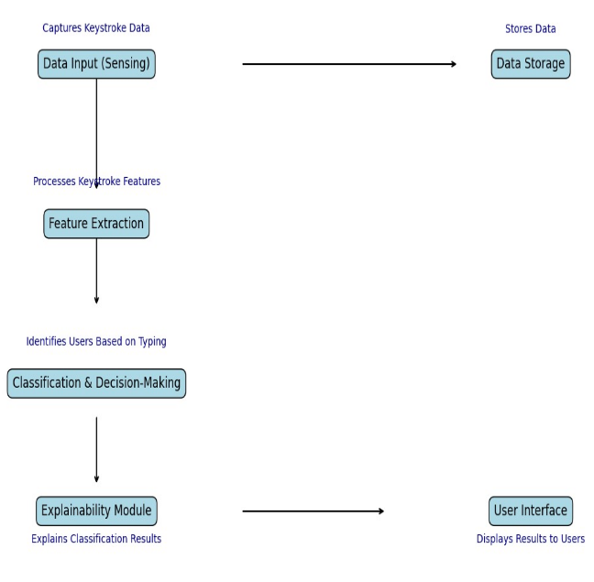
Figure 1: workflow visualization
We will collect our data directly from participants by recording their keystroke data based on predetermined sentences which they will have to type. The processed features will be used to train a Decision Tree Classifier for user identification:
- Data Preprocessing:
  - Labels (participant names) were encoded into numeric values using a label encoder.
  - Features were standardized using StandardScaler to normalize the data and ensure uniformity.
- Model Training:
  - A Decision Tree Classifier was trained using the extracted features.
  - The classifier was limited to a maximum depth of 5 to prevent overfitting and maintain interpretability.
- Cross-Validation:
  - Stratified K-Fold Cross-Validation was used to evaluate the model's performance across multiple splits, ensuring a balanced representation of each class.
The system's performance was assessed using:
- Cross-Validation Scores: The mean accuracy across folds.
- Classification Metrics: Precision, recall, and F1-score for each class.
- Model Explainability:
  - The decision tree was visualized to highlight its structure and decision rules.
  - The decision path for individual predictions was explained by tracing the feature thresholds and nodes traversed during classification.
The trained model, along with the scaler and label encoder, was serialized using joblib for deployment. This enables future predictions without retraining, ensuring efficient scalability.
This methodology demonstrates the integration of raw keystroke data collection, feature engineering, and explainable machine learning into a robust biometric authentication system. The use of interpretable models like Decision Trees, coupled with advanced feature extraction and rigorous evaluation, ensures accuracy and trustworthiness in identifying users based on their typing patterns. This system highlights the potential of keystroke dynamics as a non-intrusive and scalable biometric modality.

4. Data

A custom-built graphical user interface (GUI) application was developed using PyQt5 to capture raw keystroke data during a typing test. Participants were asked to type a predefined sentence multiple times. For each keystroke, the system recorded:
- Key Press and Release Timestamps: Captures the time a key was pressed and released.
- Key Identifiers: Logs the character or key associated with the event.
- Event Type: Differentiates between key press (keydown) and key release (keyup) events.
The raw data was stored in JSON format for further processing. Each participant's data was separated by typing attempts to ensure granularity and reproducibility.
The collected raw keystroke data was processed to extract meaningful biometric features:
- Hold Time: The duration for which a key was pressed.
- Inter-Key Interval: The time between releasing one key and pressing the next.
- Typing Speed: The number of characters typed per second.
- Error Rate: The frequency of backspace key presses.
- Statistical Features:
  - Mean, standard deviation, skewness, and kurtosis of hold times and inter-key intervals.
  - Separate statistics for vowels and consonants to account for linguistic variations.
The extracted features were saved alongside the raw data to facilitate reproducibility. The extracted dataset was transformed into a structured format (Pandas DataFrame) for machine learning.

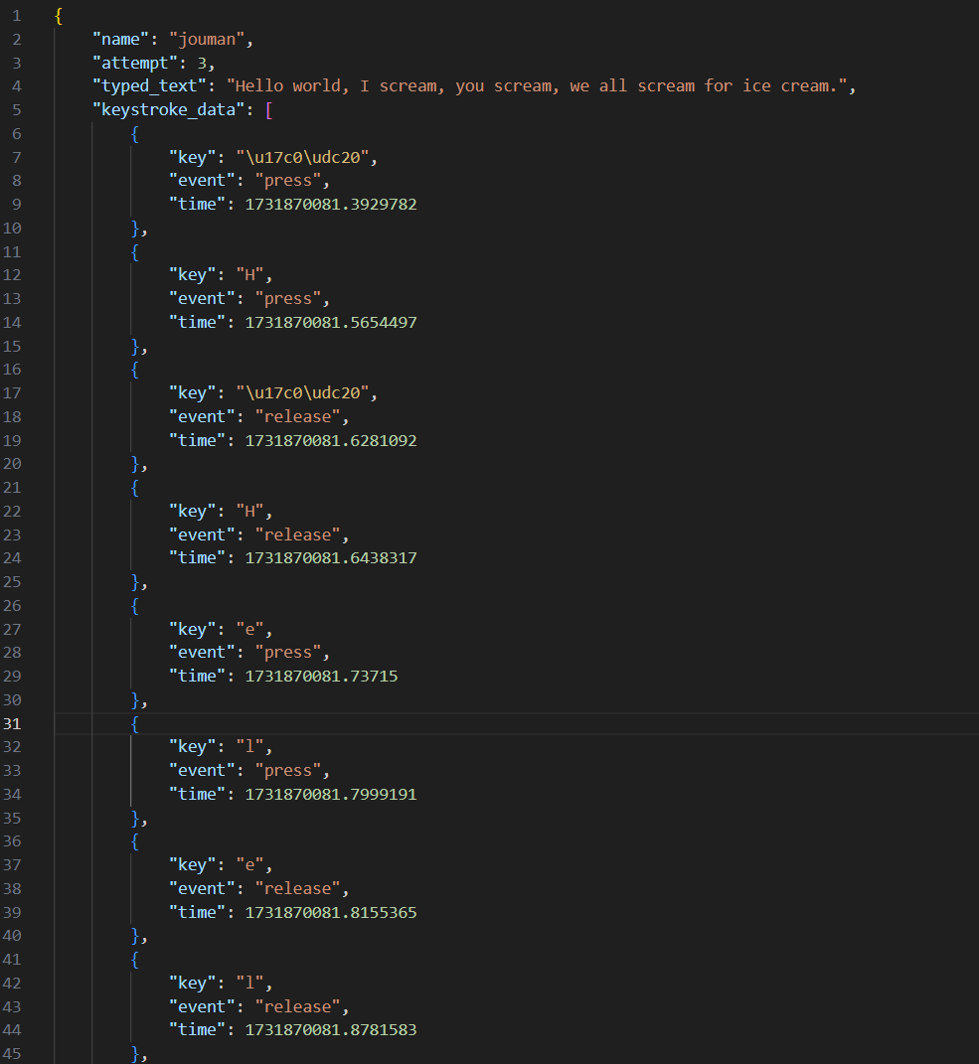
Figure 2: Sample of the raw data collected

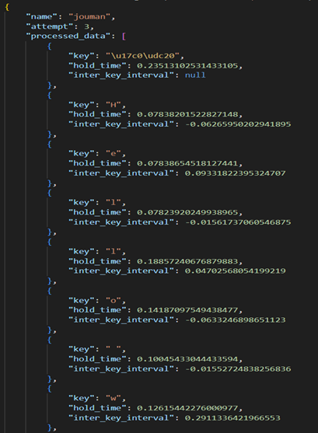
Figure 3: Sample of the processed data
5. Results

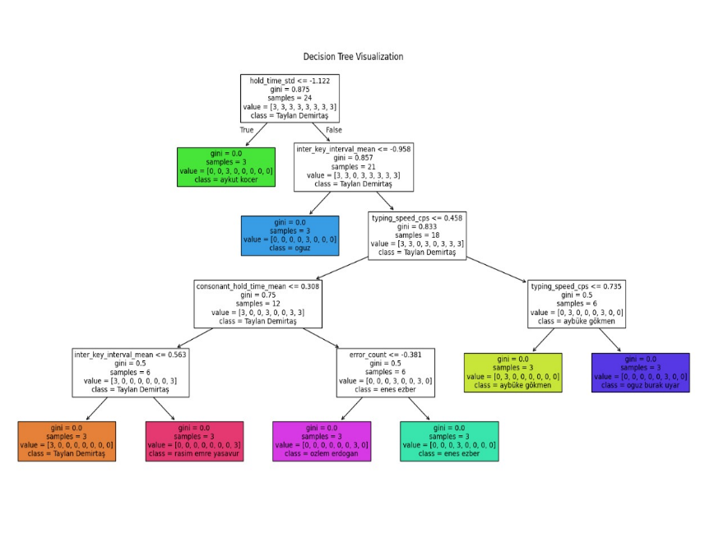
Figure 4: Results of the Decision Tree classifier on a set of participants

Figure 5: Performance Evaluation

6. Evaluation

The performance of the keystroke biometric system was assessed using a detailed classification report, which provided insights into its effectiveness in identifying individual users. The evaluation focused on metrics such as precision, recall, F1-score, and support. Precision measures the accuracy of the predictions made for each user, while recall evaluates how effectively the system identifies all true instances of a user. The F1-score combines precision and recall into a single measure, and support indicates the number of true samples available for each user, offering context for the performance metrics.
The system showed strong performance for a few users. For example, the identification of "jouman" and "ozlem erdogan" was highly accurate, with both users achieving precision scores of 0.75 and perfect recall scores of 1.00. These results imply that the system correctly identified all instances of these users while minimizing false positives. Their corresponding F1-scores of 0.86 reflect a balanced and reliable performance. However, the system struggled with other users, such as "aybüke gökmen," "imran durak," "numan," and "rasim emre yasavur," for whom the precision, recall, and F1-scores were all recorded as 0.00. This indicates that the system was unable to correctly identify any instances of these users, raising questions about the adequacy of their feature representation or possible overlaps with other users’ typing patterns.
Performance for some users, such as "aykut kocer" and "enes ezber," was mixed. For instance, "aykut kocer" achieved a precision of 1.00, meaning all predictions made for this user were correct, but a recall of 0.67 suggests that the system failed to identify some true instances. On the other hand, "enes ezber" achieved a recall of 1.00, identifying all true instances correctly, but a lower precision score indicates some false positives. Users like "oguz" and "oguz burak uyar" showed moderate performance, with F1-scores of 0.40 and 0.29, respectively. While these results indicate that the system managed to identify some instances correctly, the relatively low recall scores highlight areas where the model struggled.

7. Conclusion and Comments
Overall, the system achieved an accuracy of 42%, meaning that slightly less than half of all instances were correctly classified. The macro-average precision, recall, and F1-scores—at 0.34, 0.42, and 0.35, respectively—highlight a disparity in the system’s performance across different users. These metrics treat all users equally, underscoring the system’s difficulty in handling certain classes effectively. The weighted averages, which account for the number of samples per user, aligned closely with the macro averages, reflecting the relatively balanced distribution of samples across users.
The report highlights several challenges in the system’s performance. For some users, such as "jouman" and "ozlem erdogan," the system performed exceptionally well, but for others, it struggled significantly. This variability may stem from the limited training data available for each user—only three samples per individual—which likely constrained the system’s ability to learn distinctive patterns. Additionally, the complete failure to identify some users suggests that their typing features were either not well-represented or overlapped significantly with those of other users, complicating the classification task.
Improvements to the system could focus on increasing the volume of training data, as a larger dataset would allow for better representation of each user’s typing patterns. Further, refining the feature extraction process—perhaps by incorporating features like key sequences or analyzing linguistic patterns—could enhance the distinctiveness of user profiles. Exploring more sophisticated models, such as Random Forests or Support Vector Machines, might also improve the system’s ability to capture complex patterns and relationships in the data. Addressing class imbalances, either through oversampling techniques or by weighting the training process to favor underrepresented classes, could also help improve overall performance.
In summary, while the system demonstrated some promising results for certain users, its inconsistent performance across the dataset reveals clear areas for improvement. By increasing training data, enhancing feature engineering, and refining the classification model, the system has the potential to achieve much greater reliability and accuracy in identifying users based on their typing dynamics. This evaluation not only underscores the system’s capabilities but also highlights a roadmap for its future development.

8. References

[1] González-Silot, Santiago. "Enhancing Trustworthiness in NLP Systems Through Explainability." (2024).
[2] Radiuk, Pavlo, et al. "Explainable Artificial Intelligence: Transitioning DL Model Decisions to User-Understandable Features in Healthcare." (2024).
[3] Förster, Maximilian, et al. "Choose Wisely: Leveraging Explainable AI to Support Reflective Decision-Making." (2024).
[4] Bobek, Szymon, et al. "User-centric evaluation of explainability of AI with and for humans: a comprehensive empirical study." arXiv preprint arXiv:2410.15952 (2024).
[5] Balaji, V., and P. Selvaraj. "Combining Learning Algorithms with Explainable AI to Assess the Strength of Steganography Passwords." Steganography-The Art of Hiding Information. IntechOpen, 2024.
[6] Mazzeo, Pier Luigi, Cosimo Distante, and Loris Cino. "Skin Lesions Classification Through Test Time Augmentation And Explainable Artificial Intelligence." Available at SSRN 4981896.
[7] Kharchenko, Vyacheslav, and Oleg Odarushchenko. "Trustworthy AI Systems from Untrustworthy Components: Development von Neumann’s Paradigm using Principle of Diversity." Proceedings http://ceur-ws. org ISSN 1613 (2024): 0073.
[8] Tahir, H. Ahmed, et al. "A Novel Hybrid XAI Solution for Autonomous Vehicles: Real-Time Interpretability Through LIME–SHAP Integration." Sensors 24.21 (2024): 6776.
[9] Farook, Taseef Hasan, et al. "Application of 3D neural networks and explainable AI to classify ICDAS detection system on mandibular molars." The Journal of Prosthetic Dentistry (2024).
[10] Minh, Dang, et al. "Explainable artificial intelligence: a comprehensive review." Artificial Intelligence Review (2022): 1-66.
[11] o Guidotti, R., et al. (2018). A Survey of Methods for Explaining Black Box Models. ACM Computing Surveys.
[12] o Killourhy, K. S., & Maxion, R. A. (2009). Comparing anomaly-detection algorithms for keystroke dynamics. 2009 IEEE/IFIP International Conference on Dependable Systems & Networks.

